**4.3. Development Model**

The researcher has chosen the Waterfall Methodology because it gave a direction to the linear - sequential life cycle. It allows for departmentalization and control. A schedule can be set with deadlines for each stage of development and a product can proceed through the development process model phases one by one.

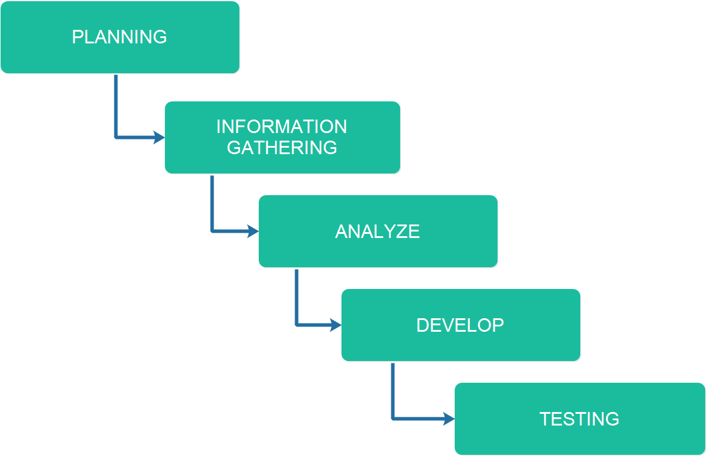

**Figure 4 –** *Waterfall Methodology for Public Vehicle Complaint Management System*

**Development 1. Planning**

This is where the researchers brainstorm for building an idea of a startup system. The researchers also picture out the design of the system by using their combined ideas.

**Development 2. Information Gathering**

The Information Gathering is where the researchers will search for the related system that supports in the development of the system. In this way, the researchers will get some ideas from the related systems and will be implemented in the system when in development method.

**Development 3. Analyze**

The gathered information will be analyzed and evaluated from the document for the development of the system. This is where the researchers will make the system flowchart.

**Development 4. Develop**

The researchers will start the coding of the back – end and the front – end. This is where the researchers develop the system’s functionalities and modules as stated in the documents.

**Development 5. Testing**

This is where the developers will test and evaluate the system. The developers will provide comments and recommendations to the researchers for revision purposes. If there are bugs and errors bump into, it will be identify easily and will be revise and change immediately.